**Social Network ADS**

**Abstract:**

Social network platform is becoming a modern advertisement platform where tech giants like Facebook, google’s major revenue are generated. Here in this project, we will predict whether the customer will click the ad using Naive Bayes.

**Data Set:**

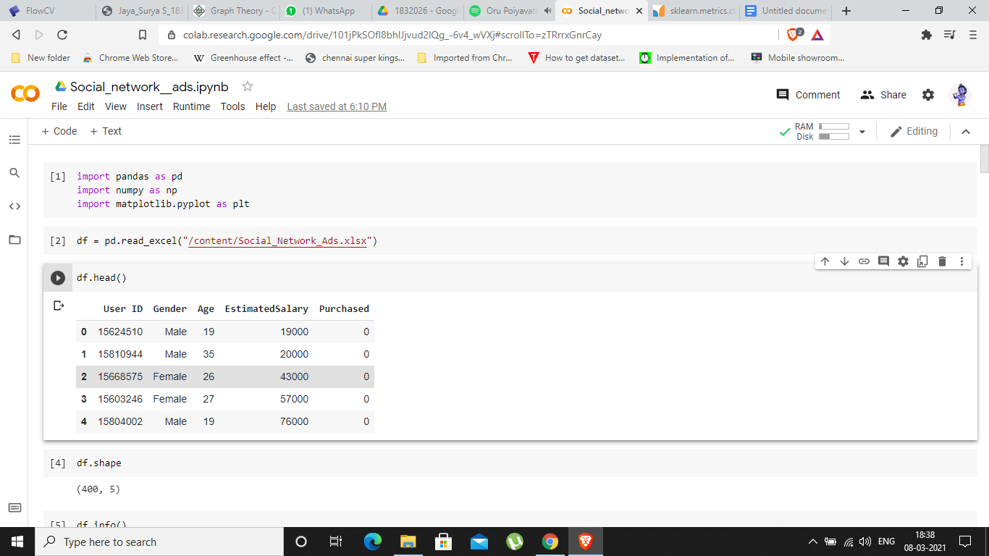

User Id, gender, age, Estimatedsalary are the independent variable and purchased is the dependent variable.

**Model:**

(400, 5)

The dataset contains 400 records and 5 features.

RangeIndex: 400 entries, 0 to 399

Data columns (total 5 columns):

# Column Non-Null Count Dtype

--- ------ -------------- -----

0 User ID 400 non-null int64

1 Gender 400 non-null object

2 Age 400 non-null int64

3 EstimatedSalary 400 non-null int64

4 Purchased 400 non-null int64

dtypes: int64(4), object(1)

memory usage: 15.8+ KB

No.of duplicate records are 0

From the above output, we see no null value, and there are no duplicate records.

**Data Visualization:**

**Box plot:**

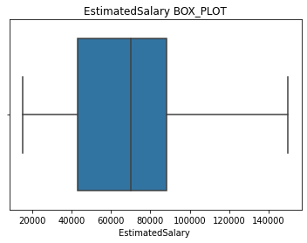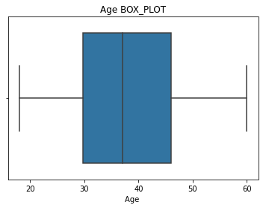

**Bar graph:**

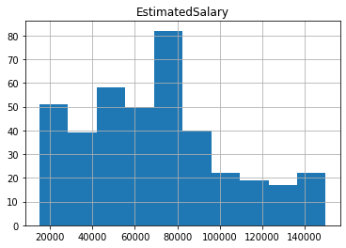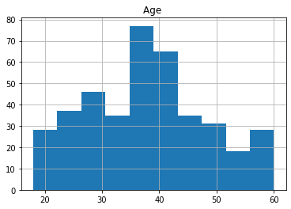

**Pie Chart:**

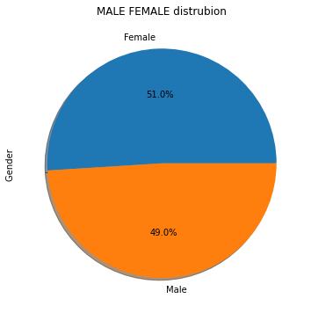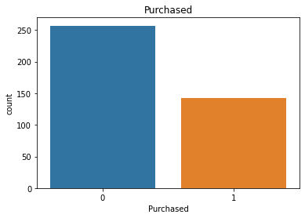

**Scatter Plot:**

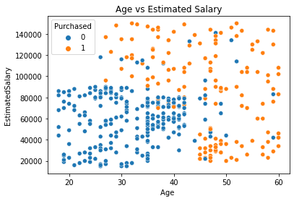

**Interpretation:**

From the boxplot, we can infer that there is no outlier in the dataset.

The bar graph shows us the distribution of the Estimatedsalary and Age.

Pie charts show us the distribution of male and female.

**Result:**

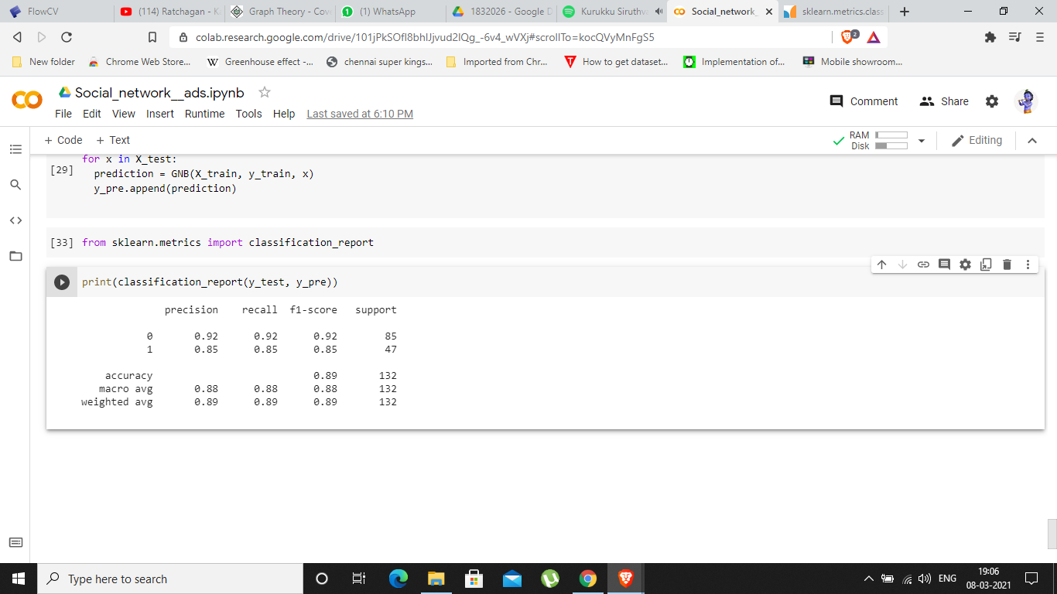

The precision of the model is 0.92 and 0.85 means the model predicts 9/10 correctly if the customer doesn’t click the add and 85/100 if the customers click the add.